**To Do List App built in Tkinter**

Features:

* Add To-Do’s
* Delete To-Do’s
* Load To-Do’s
* Save To-Do’s

The to-do list you save saves to a .txt file. When you first open the application, you must press the 'load' button.

To save every task, select and press save.

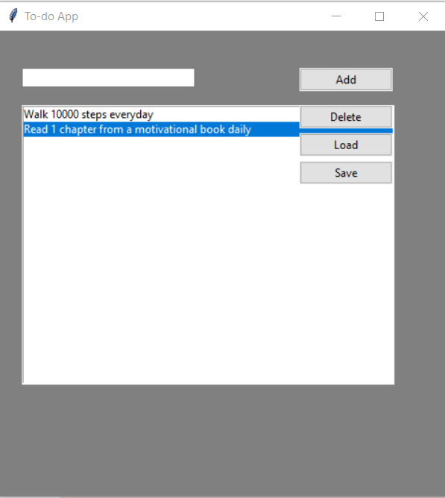

**Changes to be made to the code.**

You must write the location of the db.txt file on your computer to the URL variable in the code.

**Path:** /Users/sowmya.singh/Downloads/db.txt